Credit Card Fraud Detection: Ensuring Financial Transaction Security.

Kanishka. A. Sarangdhar

School of Computer Science and Engineering

Lovely Professional University, Jalandhar

Kanishkasarangdhar44@gmail.com

**Abstract**

Fraud detection in financial transactions is critical for maintaining the integrity and security of financial systems, especially in today's digital age. The proliferation of online banking, e-commerce, and digital payments has significantly increased the volume and complexity of financial transactions, making them more vulnerable to various types of fraudulent activities. This paper comprehensively examines the procedures and challenges associated with detecting fraud in financial transactions, with a particular focus on credit card fraud using logistic regression, linear regression and decision tree . Fraudsters employ various tactics, such as phishing scams and data breaches, to obtain card information illicitly. In response to the diverse schemes of fraud, various techniques have been developed for fraud detection, including rule-based systems, anomaly detection, and machine learning algorithms. However, financial institutions and regulatory bodies face challenges such as the rapidly evolving nature of fraud schemes and the balance between security and customer convenience. Overall, effective fraud detection requires continuous innovation, collaboration, and vigilance. By leveraging advanced technologies and adopting proactive measures, financial systems can mitigate risks and maintain trust and confidence in financial transactions.

**1 Introduction**

Fraud is a significant issue in the financial sector, with cybercriminals increasingly targeting critical infrastructure and public services through sophisticated attacks. Fraudulent activities, such as identity theft, credit card fraud, money laundering, insider trading, investment fraud, insurance fraud, and phishing scams, inflict emotional, mental, and financial harm on society, making it a top priority for governments and the financial sector. To combat this escalating threat landscape, modern financial investigations must leverage data mining and advanced data analysis techniques to detect fraudulent activities effectively. These techniques involve sifting through vast amounts of digitized financial data, which may be obscured by various forms of dishonesty, to uncover untrue statements, intent to deceive, reliance by the victim, and resulting damage. By understanding the various types of fraud and utilizing advanced data analysis techniques, stakeholders in the financial sector can proactively combat fraudulent activities, safeguard financial systems, and protect against financial losses and reputational damage. Detecting and preventing credit card fraud is not only essential for safeguarding the financial interests of consumers but also critical for maintaining trust and confidence in the financial ecosystem. Every fraudulent transaction not only results in financial losses for the victim but also undermines the credibility of the entire payment infrastructure. Therefore, there is an urgent need to develop robust and efficient fraud detection systems capable of identifying fraudulent activities in real-time.

Keywords: Credit card. Fraud Detection. Logistic Regression. Linear regression. Decision Tree

**2 Literature Review**

This study surveys different approaches to credit card fraud detection mechanisms and assesses each methodology according to specific design standards.[1] This study demonstrates how data mining approaches can be effectively used to achieve a low or high false alarm rate along with a high fraud coverage.[2] We talk about the network's performance on this data set in terms of early fraud detection and accurate detection. The technology is presently being used by Mellon Bank for credit card fraud detection on an IBM 3090 that the bank has deployed.[3] The best accuracy rates for the logistic regression, k-nearest neighbor, and naïve bayes classifiers are 54.86%, 97.69%, and 97.92%, respectively. The comparative findings demonstrate that logistic regression and naïve bayes approaches are outperformed by k-nearest neighbor.[4] In this study, we address three important issues—unbalanced, non-stationarity, and assessment—from the practitioner's point of view. Our industrial partner provides an actual credit card dataset that enables the study.[5] In this study, we employ a Hidden Markov simulate (HMM) to simulate the credit card transaction processing sequence of operations and demonstrate its potential for fraud detection. An HMM is trained using the cardholder's typical behavior. An incoming credit card transaction is deemed fraudulent if the HMM does not accept it with a high enough likelihood. We showcase comprehensive test findings to demonstrate the efficacy of our methodology.[6] We analyze and assess several methods that tackle these three primary problems simultaneously in this article. Our empirical results show that we may greatly minimize loss due to fraud using distributed data mining of fraud models. Our proposed methods of merging numerous learnt fraud detectors under a "cost model" are broad and clearly useful.[7] The experiment employed the Random Forest, Multilayer Perceptron, Naive Bayes, and Logistic Regression algorithms. The findings indicate that every algorithm has a high degree of accuracy when it comes to detecting credit card fraud. The suggested model can be applied to find further anomalies.[8] In this work, we will attempt to identify fraudulent transactions using both genetic algorithms and neural networks. As we'll see, an artificial neural network that has received the proper training can function similarly to a human brain. However, it is impossible for an ANN to fully mimic the functioning of a human brain; both the brain and the neural network rely on neurons, which are the brain's tiny functional units. To create a neural network for our credit card fraud detection problem, genetic algorithms are employed to determine the network architecture, number of hidden layers, and number of nodes. For artificial neural network learning [9] There are three main contributions in this paper. First, with the assistance of our industry partner, we put up a formalization of the fraud-detection problem that accurately characterizes the day-to-day operational conditions of FDSs that process enormous volumes of credit card transactions. Additionally, we provide examples of the best performance metrics to apply to fraud detection. Secondly, we develop and evaluate a unique learning approach that successfully tackles verification delay, idea drift, and class imbalance. Third, we show in our studies the effects of concept drift and class imbalance on a real-world data stream with over 75 million allowed transactions over a three-year period.[10] We used a European credit card fraud dataset for this paper.[11] The behavior aspects of both normal and aberrant transactions are trained using two different types of random forests in this paper. We investigate the performance of the two random forests in detecting credit fraud by comparing them, while having different base classifiers. Our experiments used data from a Chinese e-commerce company.[12] In this work, we extend the transaction aggregation technique and suggest developing a new set of features based on the von Mises distribution analysis of the periodic behavior of a transaction's time. Next, we compare state-of-the-art credit card fraud detection models and assess the effects of various feature sets on the findings using an actual credit card fraud dataset given by a major European card processing company. The findings indicate that incorporating the suggested periodic aspects into the techniques increased savings by an average of 13%.[13] In order to capture the inherent patterns of fraudulent activities discovered through labeled data, we present a CNN-based fraud detection system in this study. A convolutional neural network is applied to a feature matrix containing abundant transaction data to extract a collection of latent patterns for each sample. Tests conducted on actual large-scale transactions from a major commercial bank show that it performs better than some cutting-edge techniques.[14] The accuracy, precision, recall, and F1-score of the two algorithms are used to compare their outcomes. The confusion matrix is used to plot the ROC curve. When the Random Forest and Ad boost methods are compared, the approach with the highest recall, accuracy, precision, and F1-score is deemed to be the most effective one for fraud detection.[15]

**3 Methodology**

The methodology for credit card fraud detection involves several steps, including data preprocessing, model training, evaluation, and validation. Building upon the reference code provided earlier, we outline the methodology below:

1. Data Acquisition and Preprocessing:

• Import the necessary libraries such as NumPy, Pandas, and scikit-learn.

 • Load the credit card transaction dataset using Pandas.

• Perform exploratory data analysis (EDA) to understand the dataset's structure and characteristics.

• Handle missing values, if any, and perform data normalization or scaling to ensure uniformity across features.

• Split the dataset into features (X) and target variable (Y), where X contains transaction attributes and Y represents the class label (fraudulent or legitimate).

2. Data Imbalance Handling:

• Check for class imbalance in the dataset, as fraudulent transactions are typically rare compared to legitimate ones.

• Employ techniques such as under sampling, oversampling, or synthetic data generation to address class imbalance and ensure the model's robustness.

 3. Model Selection and Training:

• Choose an appropriate machine learning algorithm for classification, considering factors such as performance, interpretability, and computational efficiency.

• Train the selected model on the preprocessed dataset using the training data split obtained earlier.

• In the provided reference code, logistic regression is used as the classification algorithm. However, other algorithms such as random forest, support vector machines, or gradient boosting can also be explored based on the specific requirements and characteristics of the dataset.

4. Model Evaluation:

• Evaluate the trained model's performance using various metrics such as accuracy, precision, recall, and F1-score.

• Calculate these metrics on both the training and testing datasets to assess the model's generalization ability and identify any overfitting or underfitting issues.

 5. Hyperparameter Tuning (Optional):

• Conduct hyperparameter tuning to optimize the model's performance by fine-tuning parameters such as regularization strength, learning rate, or tree depth.

Utilize techniques such as grid search or randomized search to search for the optimal hyperparameters efficiently.

**4 Outcome**

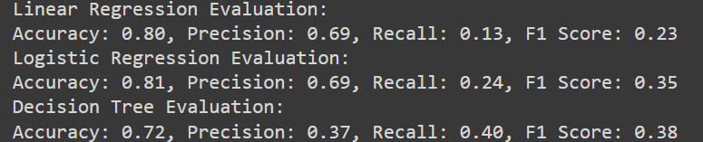

Graph:

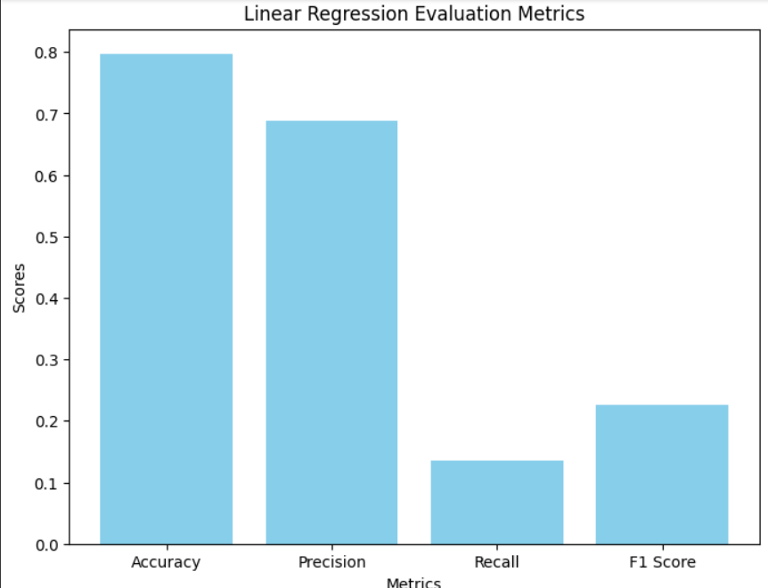

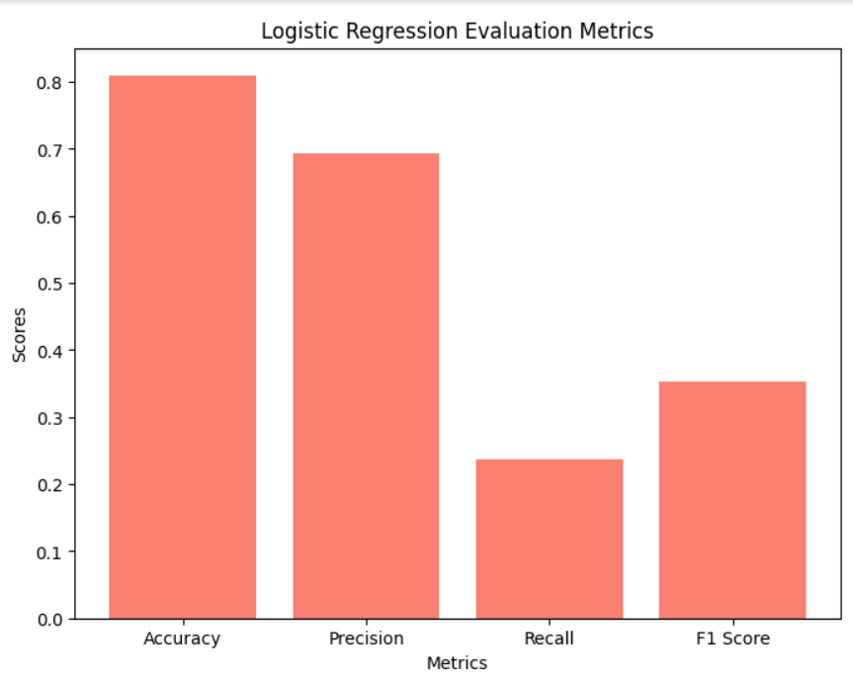

**4 Observation**

1. Data Overview:

• The dataset consists of credit card transaction data, including features such as transaction amount, time, and class labels indicating whether the transaction is fraudulent (1) or legitimate (0).

• Exploratory data analysis reveals the distribution of fraudulent and legitimate transactions, highlighting potential class imbalance issues.

  2. Data Preprocessing:

• The data preprocessing steps include checking for missing values and handling them appropriately.

• There may be a need for further preprocessing techniques such as feature scaling or normalization to ensure uniformity across features and improve model performance.

3. Data Imbalance Handling:

• The code addresses class imbalance by performing random under sampling of the majority class (legitimate transactions) to create a balanced dataset.

• Alternative techniques such as oversampling or synthetic data generation could be explored to further address class imbalance and improve model robustness.

4. Model Training and Evaluation:

The logistic regression model is trained on the preprocessed dataset to classify transactions as fraudulent or legitimate.

• Evaluation metrics such as accuracy, precision, recall, and F1-score are computed to assess the model's performance on both the training and testing datasets.

• It's important to note that while accuracy provides an overall measure of model performance, metrics like precision and recall are crucial for evaluating the model's ability to correctly identify fraudulent transactions while minimizing false positives.

5. Model Performance:

• The model achieves a certain level of accuracy, precision, recall, and F1-score on both the training and testing datasets.

• The performance metrics indicate how well the model can distinguish between fraudulent and legitimate transactions. High precision indicates a low false positive rate, while high recall indicates a low false negative rate.

**5 Future Scope**

1. Feature Engineering:

• Explore additional features or derive new features from the existing dataset to capture more nuanced patterns of fraudulent transactions.

• Investigate the incorporation of external data sources such as customer behavior analytics or transaction metadata to enhance fraud detection capabilities.

2. Advanced Machine Learning Techniques:

• Experiment with advanced machine learning algorithms beyond logistic regression, such as ensemble methods (e.g., random forest, gradient boosting), deep learning models (e.g., neural networks), or anomaly detection algorithms.

• Evaluate the performance of these algorithms and compare them with the baseline logistic regression model to identify the most effective approach for credit card fraud detection.

3. Real-Time Detection and Deployment:

• Develop mechanisms for real-time fraud detection and prevention to enable timely intervention and mitigation of fraudulent activities.

• Implement the trained model into production systems and integrate it with existing fraud detection pipelines for seamless deployment in financial institutions' operational workflows.

**6 Conclusion**

By analyzing a comprehensive dataset containing information about credit card transactions, the project demonstrates the feasibility of building a classification model capable of distinguishing between legitimate and fraudulent transactions. The logistic regression model serves as a starting point, providing a baseline for evaluating model performance and effectiveness in fraud detection.

The project highlights several key observations and areas for improvement, including data preprocessing, handling imbalanced data, exploring advanced machine learning algorithms, and enhancing model interpretability. These insights lay the groundwork for future research and development efforts aimed at enhancing the robustness and accuracy of fraud detection systems.

Overall, the credit card fraud detection project underscores the importance of leveraging data-driven approaches to address the growing threat of fraudulent activities in financial transactions. By harnessing the power of predictive modeling and analytics, stakeholders can work towards building more resilient and effective fraud detection systems to protect consumers, merchants, and financial institutions from the impacts of fraudulent transactions.

**7 References**

1.Raj, S. Benson Edwin, and A. Annie Portia. "Analysis on credit card fraud detection methods." 2011 International Conference on Computer, Communication and Electrical Technology (ICCCET). IEEE, 2011.

2. Chaudhary, Khyati, Jyoti Yadav, and Bhawna Mallick. "A review of fraud detection techniques: Credit card." International Journal of Computer Applications 45.1 (2012): 39-44.

3. Ghosh, Sushmito, and Douglas L. Reilly. "Credit card fraud detection with a neural network." System Sciences, 1994. Proceedings of the Twenty-Seventh Hawaii International Conference on. Vol. 3. IEEE, 1994.

4. Awoyemi, John O., Adebayo O. Adetunmbi, and Samuel A. Oluwadare. "Credit card fraud detection using machine learning techniques: A comparative analysis." 2017 international conference on computing networking and informatics (ICCNI). IEEE, 2017.

5. Dal Pozzolo, Andrea, et al. "Learned lessons in credit card fraud detection from a practitioner perspective." Expert systems with applications 41.10 (2014): 4915-4928.

6. Srivastava, Abhinav, et al. "Credit card fraud detection using hidden Markov model." IEEE Transactions on dependable and secure computing 5.1 (2008): 37-48.

7. Chan, Philip K., et al. "Distributed data mining in credit card fraud detection." IEEE Intelligent Systems and Their Applications 14.6 (1999): 67-74.

8.Varmedja, Dejan, et al. "Credit card fraud detection-machine learning methods." 2019 18th International Symposium INFOTEH-JAHORINA (INFOTEH). IEEE, 2019.

9.Patidar, Raghavendra, and Lokesh Sharma. "Credit card fraud detection using neural network." International Journal of Soft Computing and Engineering (IJSCE) 1.32-38 (2011).

10. Dal Pozzole, Andrea, et al. "Credit card fraud detection: a realistic modeling and a novel learning strategy." IEEE transactions on neural networks and learning systems 29.8 (2017): 3784-3797.

11. Dornadula, Vaishnavi Nath, and Sa Geetha. "Credit card fraud detection using machine learning algorithms." Procedia computer science 165 (2019): 631-641.

12. Xuan, Shiyang, et al. "Random Forest for credit card fraud detection." 2018 IEEE 15th international conference on networking, sensing and control (ICNSC). IEEE, 2018.

13. Bahnsen, Alejandro Correa, et al. "Feature engineering strategies for credit card fraud detection." Expert Systems with Applications 51 (2016): 134-142.

14. Fu, Kang, et al. "Credit card fraud detection using convolutional neural networks." Neural Information Processing: 23rd International Conference, ICONIP 2016, Kyoto, Japan, October 16–21, 2016, Proceedings, Part III 23. Springer International Publishing, 2016.

15. Sailusha, Ruttala, et al. "Credit card fraud detection using machine learning." 2020 4th international conference on intelligent computing and control systems (ICICCS). IEEE, 2020.